
Life Expectancy (WHO)
The data contained in this dataset, which can be found in https://www.kaggle.com/datasets/kumarajarshi/life-expectancy-who, were tracked by the World Health Organization (WHO) and were made available to the public for the purpose of health data analysis. The dataset has 21 features and 2938 samples, containing information on immunization, mortality, economic, social and other health related factors. The goal is to predict the life expectancy of individuals from different backgrounds.
Isalos version used: 2.0.6

Step 1: Import data from file
Right click on the input spreadsheet (left) and choose the option “Import from File”. Then navigate through your files to load the one with the life expectancy data.
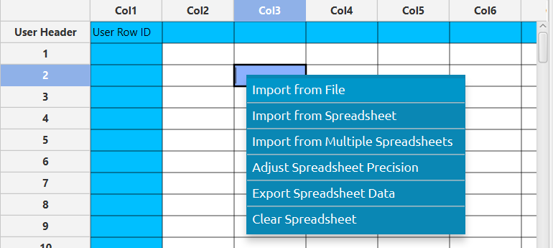

The data will appear on the left spreadsheet.
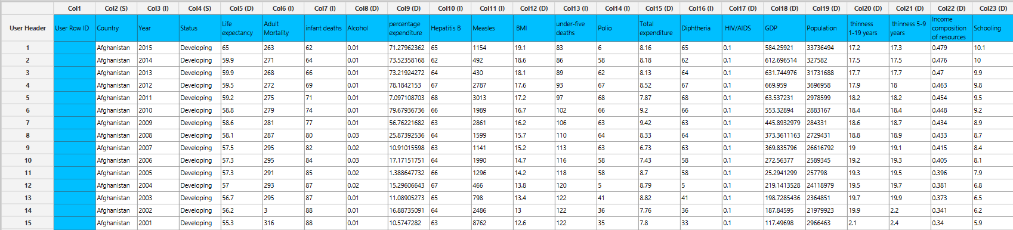

Step 2: Manipulate data
We will select all the columns to be used for predictions. On the menu click on Data Transformation $→$ Data Manipulation $→$ Select Column(s) and select all columns.
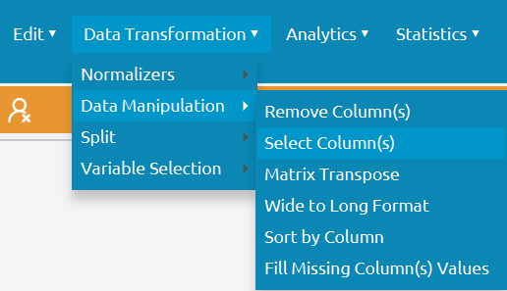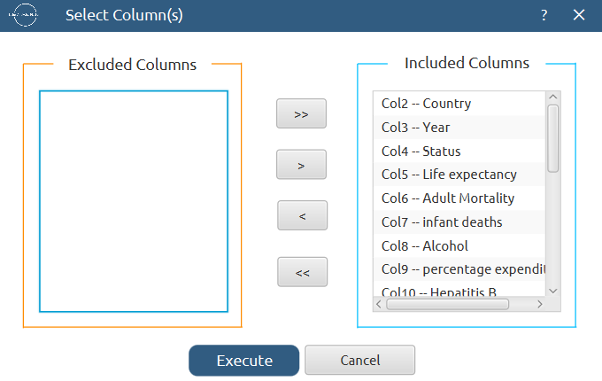

All the data will appear in the output (right) spreadsheet. This tab can be renamed “IMPORT” by right-clicking on it and choosing the “Rename” option.
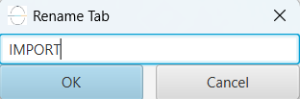

Step 3: Fill missing data
The dataset contains some missing values, so we will fill them appropriately depending on whether the corresponding factor is numerical of categorical. Create a new tab by pressing the “+” button on the bottom of the page with the name “FILL_MISSING” which we will use for filling the missing data.
Import data into the input spreadsheet of the “FILL_MISSING” tab from the output of the “IMPORT” tab by right-clicking on the input spreadsheet and then choosing “Import from Spreadsheet”.

Fill the missing values by choosing: Data Transformation $→$ Data Manipulation $→$ Fill Missing Column(s) Values
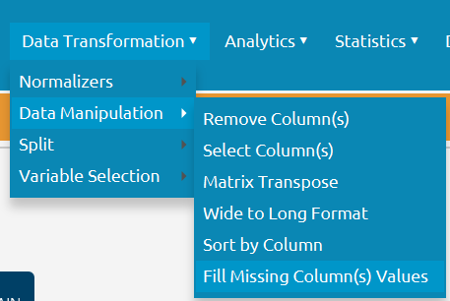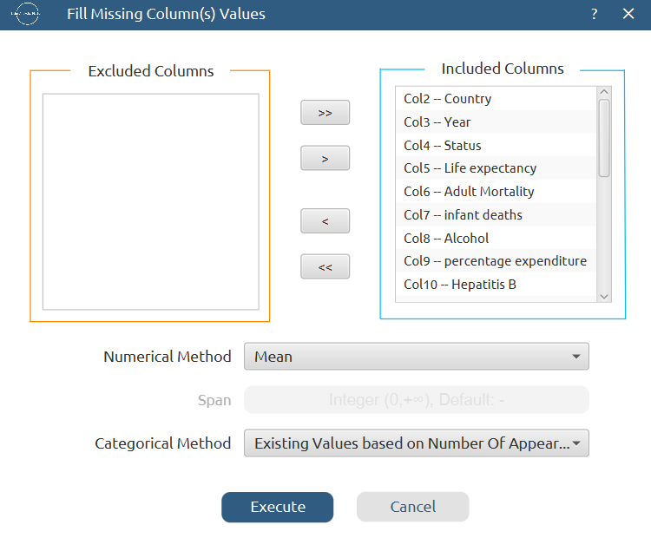

The results will appear on the output (right) spreadsheet.

Step 4: Split data
Create a new tab by pressing the “+” button on the bottom of the page with the name “TRAIN_TEST_SPLIT” which we will use for splitting the train and test set.
Import data into the input spreadsheet of the “TRAIN_TEST_SPLIT” tab from the output of the “FILL_MISSING” tab by right-clicking on the input spreadsheet and then choosing “Import from Spreadsheet”.
Split the dataset by choosing Data Transformation $→$ Split $→$ Random Partitioning. Then choose the “Training set percentage” and the column for the sampling as shown below:
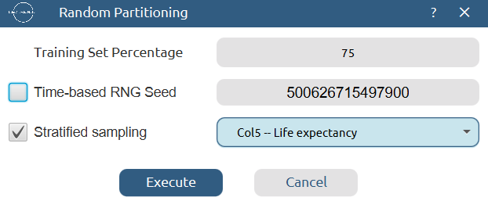

The results will be two separate spreadsheets, “TRAIN_TEST_SPLIT: Training Set” and “TRAIN_TEST_SPLIT: Test Set”, which will be available to import into the next tabs.

Step 5: Normalize the training set
Create a new tab by pressing the “+” button on the bottom of the page with the name “NORMALIZE_TRAIN_SET”.
Import into the input spreadsheet of the “NORMALIZE_TRAIN_SET” tab the train set from the output of the “TRAIN_TEST_SPLIT” tab by right-clicking on the input spreadsheet and then choosing “Import from Spreadsheet”. From the available Select input tab options choose “TRAIN_TEST_SPLIT: Training Set”.
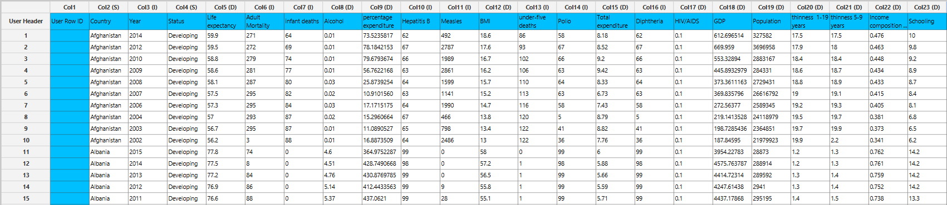

Normalize the data using Z-score: Data Transformation $→$ Normalizers $→$ Z Score and select all columns except the “Life expectancy” target column.
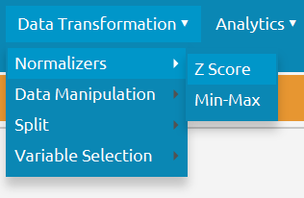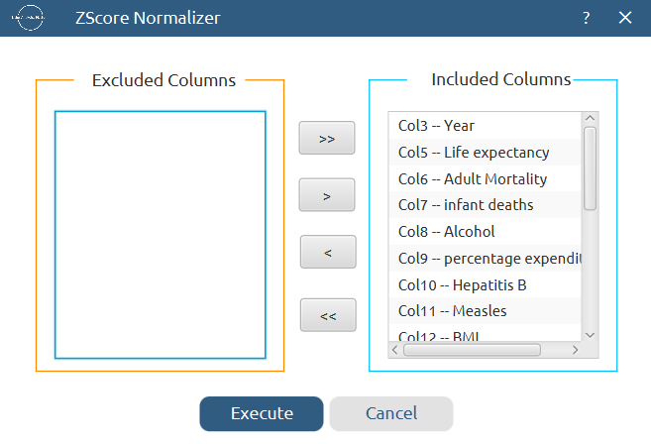

The results will appear on the output spreadsheet.
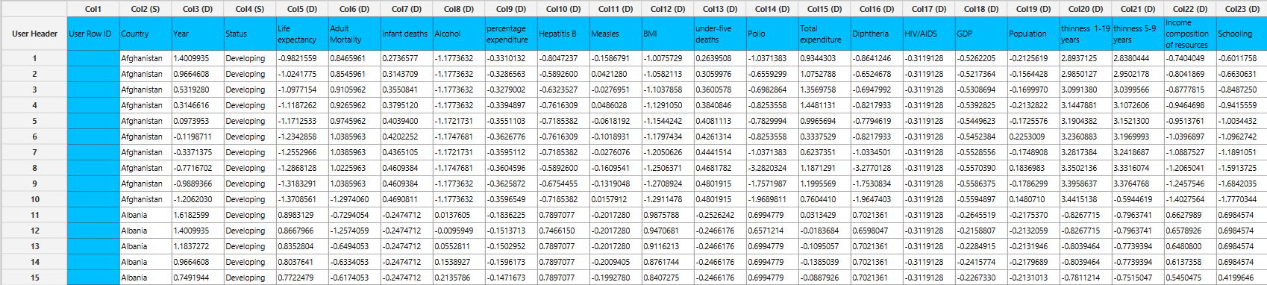

Step 6: Normalize the test set
Create a new tab by pressing the “+” button on the bottom of the page with the name “NORMALIZE_TEST_SET”.
Import into the input spreadsheet of the “NORMALIZE_TEST_SET” tab the test set from the output of the “TRAIN_TEST_SPLIT” tab by right-clicking on the input spreadsheet and then choosing “Import from Spreadsheet”. From the available Select input tab options choose “TRAIN_TEST_SPLIT: Test Set”.
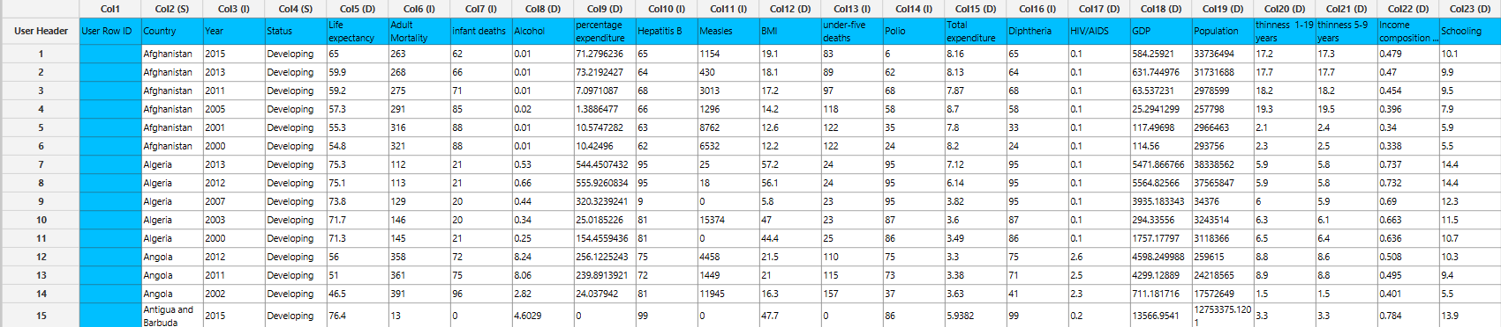

Normalize the test set using the existing normalizer of the training set: Analytics $→$ Existing Model Utilization $→$ Model (from Tab:) NORMALIZE_TRAIN_SET

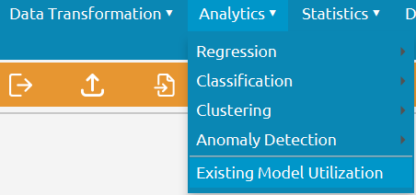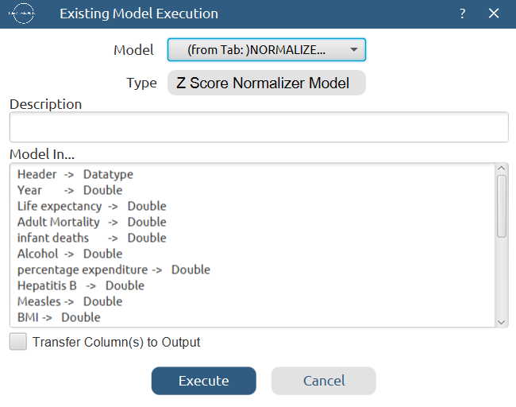

The results will appear on the output spreadsheet.
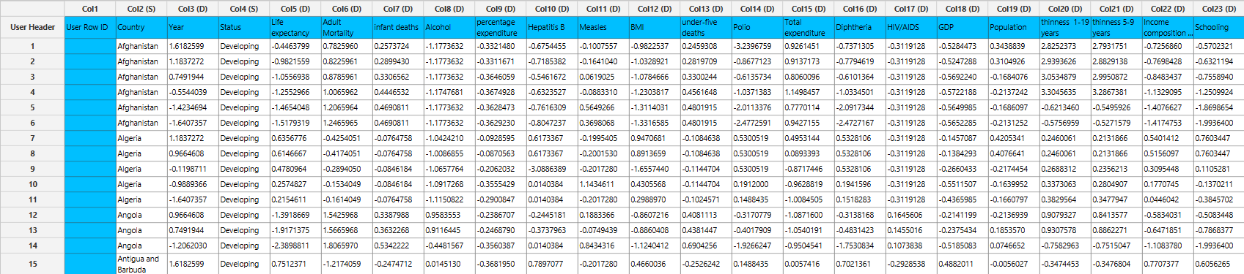

Step 7: Train the model
Create a new tab by pressing the “+” button on the bottom of the page with the name “TRAIN_MODEL(.fit)”.
Import data into the input spreadsheet of the “TRAIN_MODEL(.fit)” tab from the output of the “NORMALIZE_TRAIN_SET” tab by right-clicking on the input spreadsheet and then choosing “Import from Spreadsheet”.
Use the k-Nearest Neighbors (kNN) method to train and fit the model: Analytics $→$ Regression $→$ k-Nearest Neighbors (kNN)
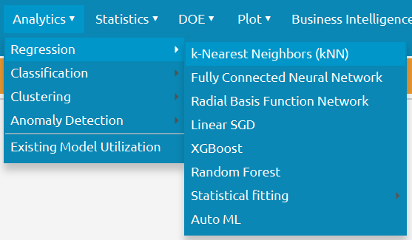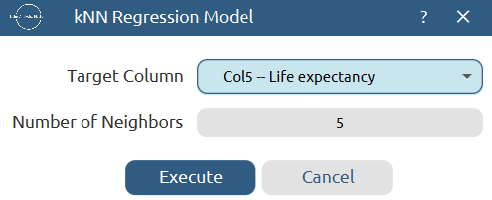

The predictions will appear on the output spreadsheet.
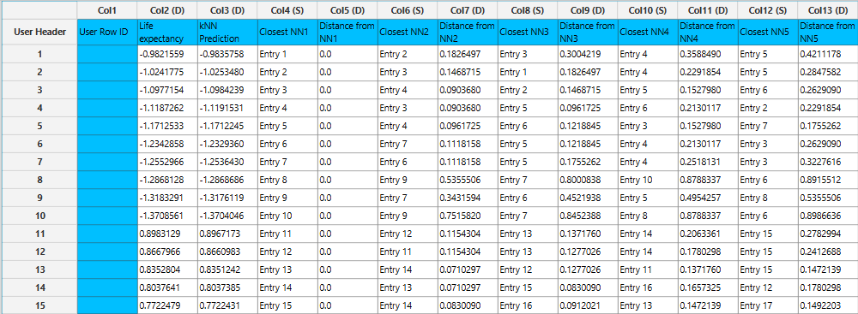

Step 8: Validate the model
Create a new tab by pressing the “+” button on the bottom of the page with the name “VALIDATE_MODEL(.predict)”.
Import data into the input spreadsheet of the “VALIDATE_MODEL(.predict)” tab from the output of the “NORMALIZE_TEST_SET” tab by right-clicking on the input spreadsheet and then choosing “Import from Spreadsheet”.
To validate the model: Analytics $→$ Existing Model Utilization$→$ Model (from Tab:) TRAIN_MODEL(.fit). Choose the column “Life expectancy” to be transferred to the output spreadsheet.
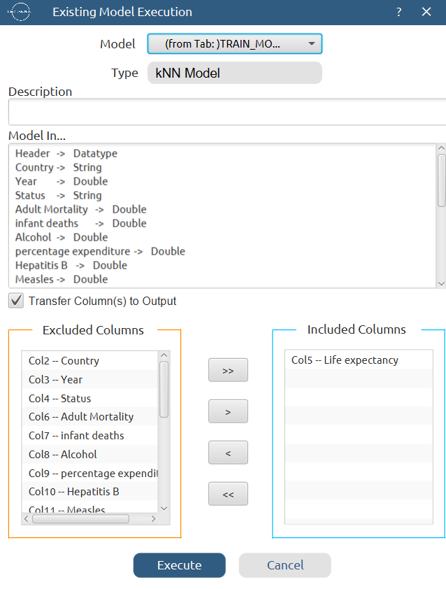

The predictions will appear on the output spreadsheet.
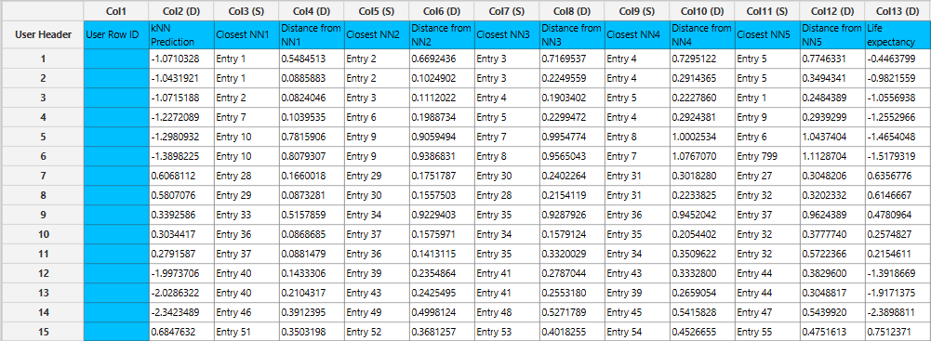

Step 9: Statistics calculation
Create a new tab by pressing the “+” button on the bottom of the page with the name “STATISTICS_ACCURACIES”.
Import data into the input spreadsheet of the “STATISTICS_ACCURACIES” tab from the output of the “VALIDATE_MODEL(.predict)” tab by right-clicking on the input spreadsheet and then choosing “Import from Spreadsheet”.
Calculate the statistical metrics for the regression: Statistics $→$ Model Metrics $→$ Regression Metrics
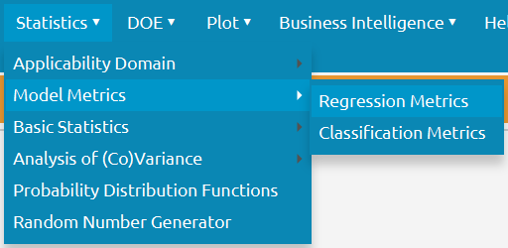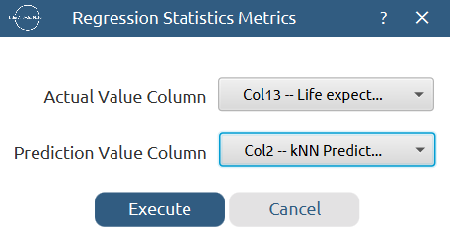

The results will appear on the output spreadsheet.
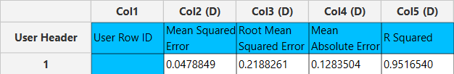

Step 10: Reliability check for each record of the test set

Step 10.a: Create the domain
Create a new tab by pressing the “+” button on the bottom of the page with the name “EXCLUDE_LIFE”.
Import data into the input spreadsheet of the “EXCLUDE_LIFE” tab from the output of the “NORMALIZE_TRAIN_SET” tab by right-clicking on the input spreadsheet and then choosing “Import from Spreadsheet”.
Manipulate the data to exclude the target column “Life expectancy”: Data Transformation $→$ Data Manipulation $→$ Select Column(s)
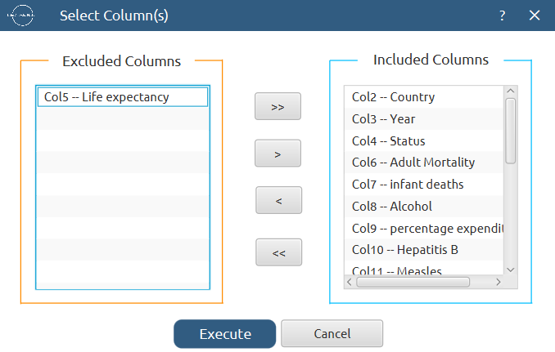

The results will appear on the output spreadsheet.
Create a new tab by pressing the “+” button on the bottom of the page with the name “DOMAIN”.
Import data into the input spreadsheet of the “DOMAIN” tab from the output of the “EXCLUDE_LIFE” tab by right-clicking on the input spreadsheet and then choosing “Import from Spreadsheet”.
Create the domain: Statistics $→$ Applicability Domain $→$ APD
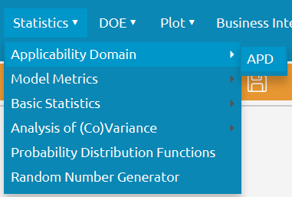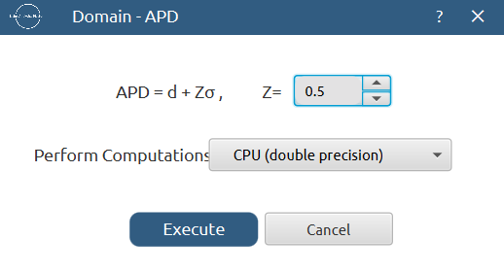

The results will appear on the output spreadsheet.
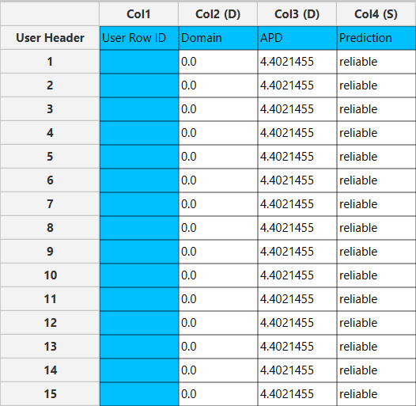

Step 10.b: Check the test set reliability
Create a new tab by pressing the “+” button on the bottom of the page with the name “EXCLUDE_LIFE_TEST_SET”.
Import data into the input spreadsheet of the “EXCLUDE_LIFE_TEST_SET” tab from the output of the “NORMALIZE_TEST_SET” tab by right-clicking on the input spreadsheet and then choosing “Import from Spreadsheet”.
Manipulate the data to exclude the target column “Life expectancy”: Data Transformation $→$ Data Manipulation $→$ Select Column(s)

The results will appear on the output spreadsheet.
Create a new tab by pressing the “+” button on the bottom of the page with the name “RELIABILITY”.
Import data into the input spreadsheet of the “RELIABILITY” tab from the output of the “EXCLUDE_LIFE_TEST_SET” tab by right-clicking on the input spreadsheet and then choosing “Import from Spreadsheet”.
Check the Reliability: Analytics $→$ Existing Model Utilization$→$ Model (from Tab:) DOMAIN
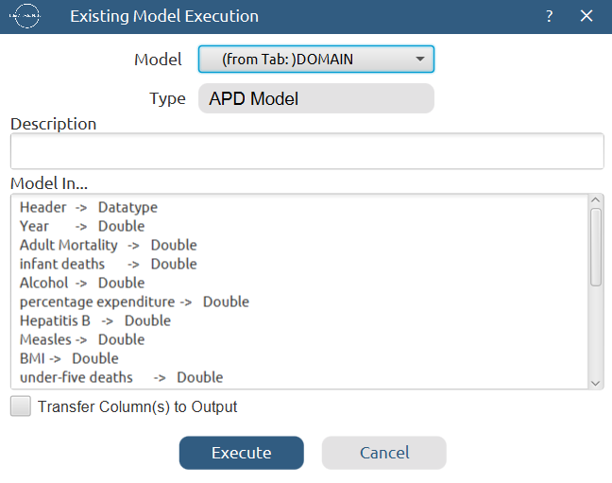

The results will appear on the output spreadsheet.
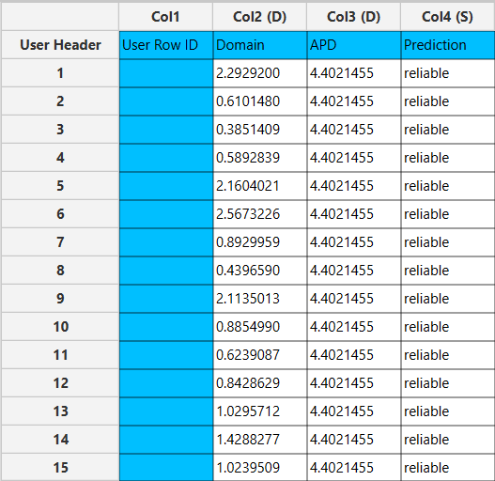

Final Isalos Workflow
Following the above-described steps, the final workflow on Isalos will look like this:
